|  |
| --- |
| Guide for implementing Survey in E-PRTR 2  Documentation |

|  |  |  |  |  |  |  |
| --- | --- | --- | --- | --- | --- | --- |
| **JOB NUMBER:** | | | **DOCUMENT REF:** | | | |
| **Version** | **Purpose of issue** | **Originated** | **Checked** | **Reviewed** | **Authorised** | **Date** |
| 1.0 | Initial Draft | Morten Hjelmsmark |  |  |  | 13.01.2016 |
|  |  |  |  |  |  |  |
| **ATKINS DANMARK** | | | | | | |

# Summary

Implementing a survey is a part of the Atkins contract 2015-2016. The task is described as: *The survey has 3 questions at the moment (it will not have more than 5). The purpose is to have it online ‘forever’ and consistently store the results so that they can be analysed at any point of time. Raw data with the results will be delivered to DG ENV upon request. Survey data will be stored in the CMS database.*

# Setup

The survey will be displayed in the E-PRTR2 site as a modal popup. The date will be saved in a cookie which means that the user won’t see the survey for the next three months, unless the user doesn’t submit or chooses no, but just closes the modal.

Because we now uses cookies we needed to implement a cookie alert.

The survey is meant as continuous part of the site, but the questions can be changed over time. For that reason the survey datamodel is designed to be flexible and the survey questions is served by a rest service.

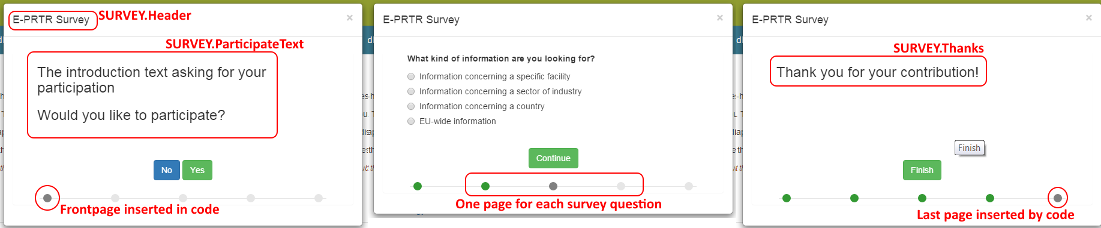The first page and the last page uses text from the CMS database (Group: **Survey**) and the middle pages uses content from the Survey tables described in the next section.

# Datamodel

The datamodel consists of three tables; SurveyMaster, SurveyItems and SurveyResults

SurveyMaster is related one to one to SurveyItems.

Each row in SurveyMaster table represents a tab / question in the survey.

**SurveyMaster**

* **SurveyText**: The question
* **SurveyLabel**: Is used by the survey wizard but currently not displayed
* **ListIndex**: number from 0 and up used to handle the order of the questions
* **Updated**: timestamp set by a trigger when the row was created or updated

**SurveyItems**

* 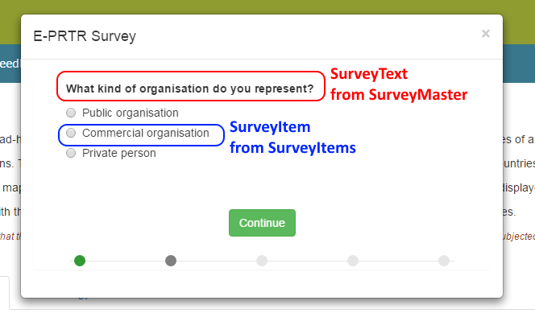**FK_SurveyID:** Relates to SurveyID
* **SurveyItem:** Multi-choice answers for the related SurveyMaster question
* **SurveyItemResultID:** The ID which is used in the result list. The ID for answer two of question 1 should be ‘1b’.
* **ListIndex**: number from 0 and up used to handle the order of the answers
* **Updated**: timestamp set by a trigger when the row was created or updated

**SurveyResults**

* **SurveyResult:** Comma separated list of answers like: 1c,2a,3d (since we don’t know the exact number of questions this is the best way to handle the results)
* **Inserted**: timestamp set by a trigger when the result is created

# Implement in the E-PRTR CMS database

To implement the tables in the E-PRTR CMS database you just need to download and run the **EPRTRSurveyDataModel.sql** script which can be found here: <https://svn.eionet.europa.eu/repositories/EPRTR/trunk/Website/EPRTR2/EPRTRSurveyDataModel.sql>

The script includes the predefined three questions and the CMS texts which will be descriped in the